### **VRINDA GUPTA**

### **500109760**

### **R2142221329**

### **B-2**

### **Lab Exercise 9- Managing Namespaces in Kubernetes**

**Step 1: Understand Namespaces**

Namespaces provide a mechanism for scoping resources in a cluster. Namespaces can be used to:

* Create environments for different applications or teams.
* Apply policies like resource quotas or network policies on a per-namespace basis.
* Separate operational environments (like development and production).

**Step 2: List Existing Namespaces**

To list all the namespaces in your Kubernetes cluster:

kubectl get namespaces

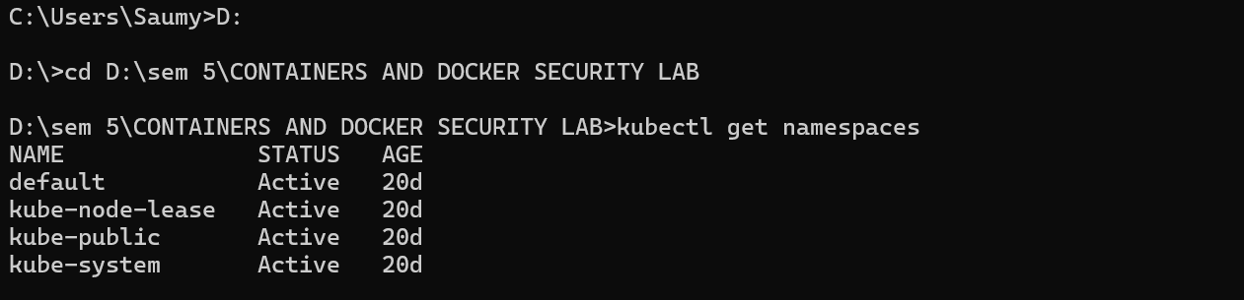

You will typically see default namespaces like default, kube-system, and kube-public.

**Step 3: Create a Namespace**

You can create a namespace using a YAML file or directly with the kubectl command.**Using YAML File**

Create a file named ***my-namespace.yaml*** with the following content:



apiVersion: v1

kind: Namespace

metadata:

name: my-namespace

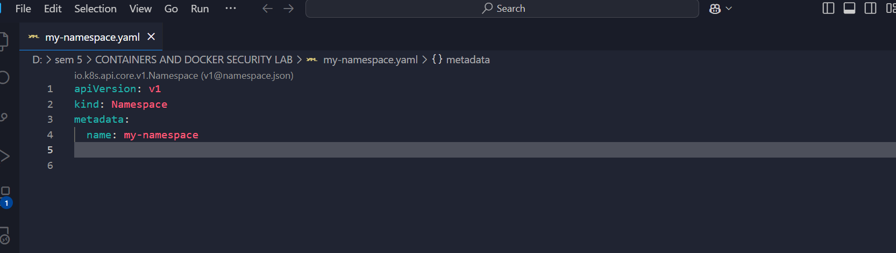

Apply this YAML to create the namespace:

kubectl apply -f my-namespace.yaml



Verify that the namespace is created:

kubectl get namespaces

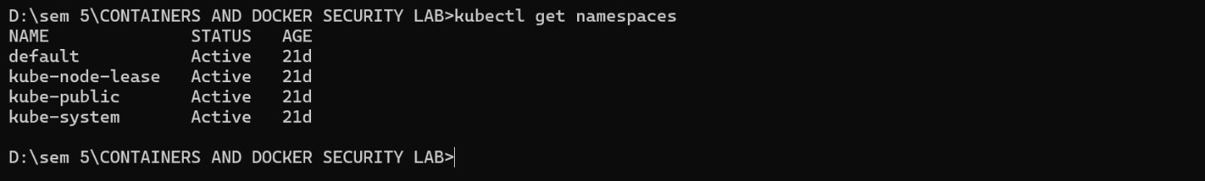

You should see my-namespace listed in the output.

**Step 4: Deploy Resources in a Namespace**

Create resources such as Pods, Services, or Deployments within the new namespace.

Deploy a Pod in the Namespace

Create a YAML file named ***nginx-pod.yaml*** with the following content:



apiVersion: v1

kind: Pod

metadata:

name: nginx-pod

namespace: my-namespace # Specify the namespace for the Pod.

spec:

containers:

- name: nginx

image: nginx:latest

ports:

- containerPort: 80

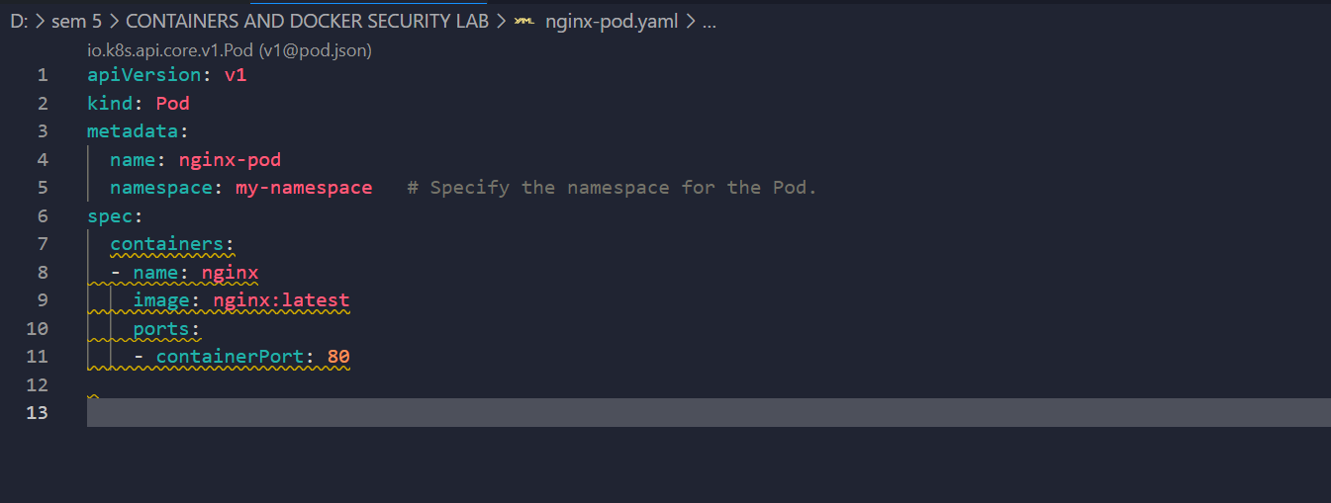

Apply this YAML to create the Pod:

kubectl apply -f nginx-pod.yaml



Check the status of the Pod within the namespace:

kubectl get pods -n my-namespace



To describe the Pod and see detailed information:

kubectl describe pod nginx-pod -n my-namespace

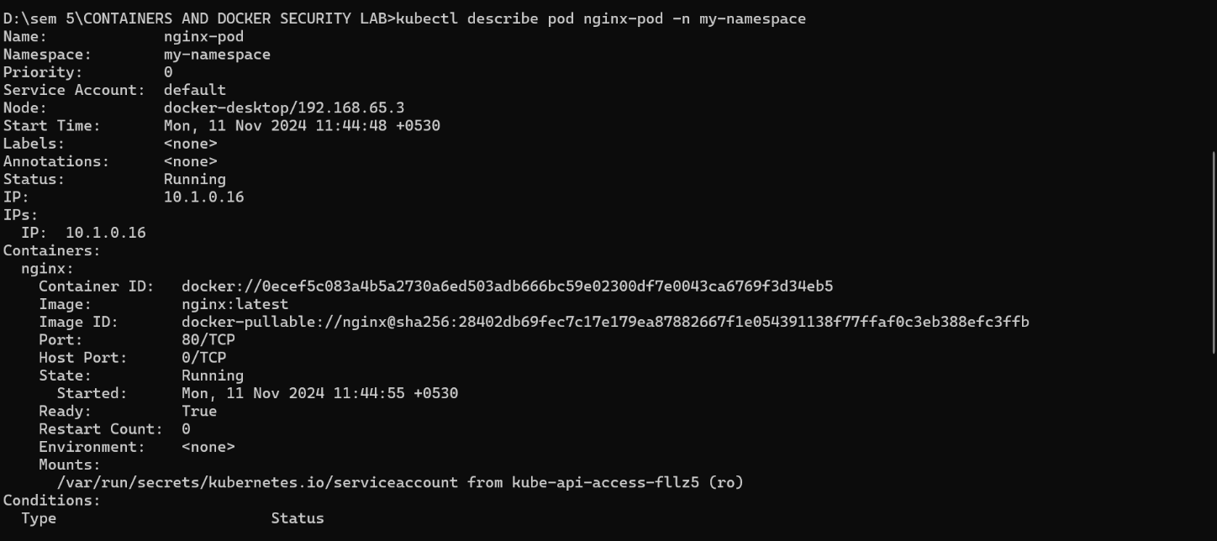

Create a Service in the Namespace

Create a YAML file named nginx-service.yaml with the following content:

apiVersion: v1

kind: Service

metadata:

name: nginx-service

namespace: my-namespace # Specify the namespace for the Service.

spec:

selector:

app: nginx-pod

ports:

- protocol: TCP

port: 80

targetPort: 80

type: ClusterIP

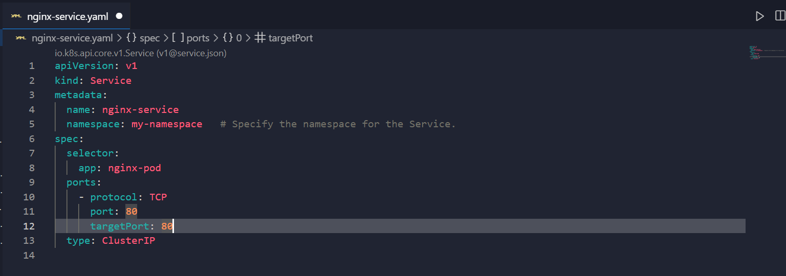

Apply this YAML to create the Service:

kubectl apply -f nginx-service.yaml



Check the status of the Service within the namespace:

kubectl get services -n my-namespace



To describe the Service and see detailed information:

kubectl describe service nginx-service -n my-namespace

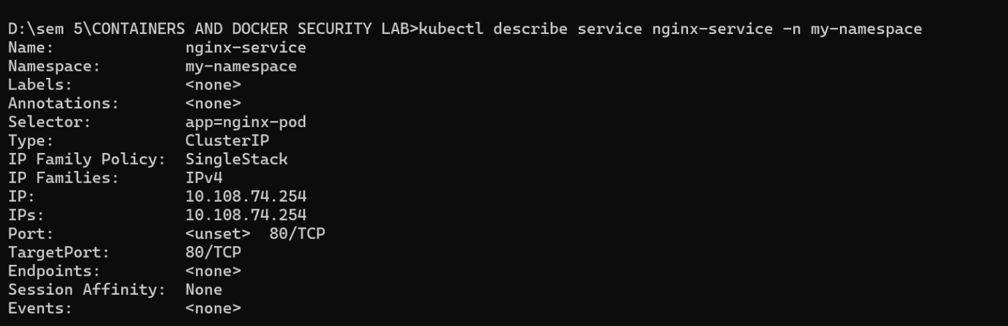

**Step 5: Switching Context Between Namespaces**

When working with multiple namespaces, you can specify the namespace in kubectl commands or switch the default context.

**Specify Namespace in Commands**

You can specify the namespace directly in kubectl commands using the -n or --namespace flag:

kubectl get pods -n my-namespace



**Set Default Namespace for kubectl Commands**

To avoid specifying the namespace every time, you can set the default namespace for the current context:

kubectl config set-context --current --namespace=my-namespace



Verify the current context’s namespace:

kubectl config view --minify | grep namespace:

**Step 6: Clean Up Resources**

To delete the resources and the namespace you created:

kubectl delete -f nginx-pod.yaml

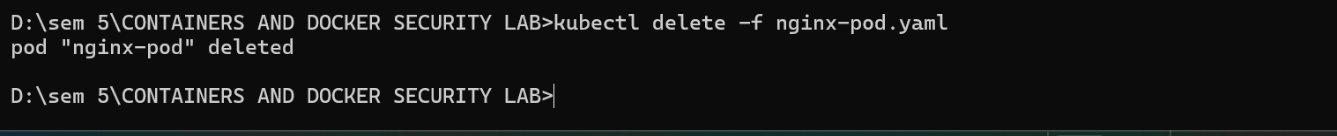

kubectl delete -f nginx-service.yaml



kubectl delete namespace my-namespace



Ensure that the namespace and all its resources are deleted:

kubectl get namespaces

